Open Destinations: 2014 Brand Guidelines
1. The story behind the new logo 2
2. Logo with Strapline 2
3. Logo without Strapline 3
4. Product logos 3
5. Other versions of the logo 4
6. Fonts 4
7. Colour scheme 5
8. E-mail signature 5
8.1 Email font instructions 5
8.2 Email signature instructions 6
9. Document template guidelines 7
10. Do’s and Don’ts *new 7
11. Work in progress 8
12. How to accessing the new document templates 8
11.1 Shared Templates 8
11.2 How to use Templates 11

The story behind the new logo

2014 also marks the 15th anniversary of Open Destinations. This milestone provides us with an opportunity to highlight our unique history and our expertise in the development of travel technology in the global space.

Our brand is now seen worldwide, not only in our documentation and our website, but also through social media channels and third party websites. This means that our brand needs to be flexible and tell our story in many different avenues, which is the reason behind the launch of our new logo and brand identity.

The story of Open Destinations has become about more than just our technology - it’s also the team of travel professionals who are behind it. The new logo has a dominant compass image, which signifies our commitment to our customers to point them in the right direction and drive their business forward, through our superior technology and our vast experience and expertise in travel.

The points in the compass highlight the 4 key areas of our business:

Travel Reservations System
• Travel Studio & Fare Studio

Supplier Integrations
• Wide range of integrations with bedbanks, car hire, payment systems and much more

Technology Consultants
• Business analysis, project management, development, training and implementation

Support Services
• Customer support and travel outsourcing

Logo with Strapline

The strapline has been adjusted to highlight our stability in the travel industry, being in business since 1999.

This version of the logo should be used in all marketing material and external documents where possible, such as customer letters and other simple documents. This logo should not be used for lengthy documents such as FSD’s, BRD’s and RFP’s where there are many pages of text and the logo takes up too much space.

Logo size:
- Minimum 1.75 cm high x 7.76 cm wide for word documents, powerpoint and other areas

Important notes:

- You should never increase/decrease (stretch) the size of the logos as this will compromise their visual impact.
- If you are changing the size of the logo, please use the picture tools function by clicking on the image – example shown below. This will help to ensure the best quality of the logo image at all times.
- To protect the logo’s integrity, please ensure that sufficient clear space is left around it. Do not clutter the logo with images, text, or other elements.


Logo without Strapline

This version of the logo should be used for lengthy documents such as FSD’s, BRD’s and RFP’s where there are many pages of text. This will also be used for internal documents and areas of our software to compliment the product logos.

Logo size:
- Minimum 1.75 cm high x 4.2 cm wide for word documents, powerpoint and other areas

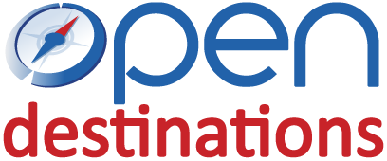

Important notes:

- You should never increase/decrease (stretch) the size of the logos as this will compromise their visual impact.
- If you are changing the size of the logo, please use the picture tools function by clicking on the image – example shown below. This will help to ensure the best quality of the logo image at all times.
- To protect the logo’s integrity, please ensure that sufficient clear space is left around it. Do not clutter the logo with images, text, or other elements.

Product logos

The product logos are to be used predominately in the software for Travel Studio and Fare Studio, as well as in some marketing material. The product logos will no longer be used in product documents (ie. FSD’s, BRD’s) as there is text to support it as a product document and the ODL logo will be dominant. This ensures that we are making the best use of space in our documents and providing clients with a clean, clear message with Open Destinations as the dominant logo.

If you would like to incorporate these logos into any new documents, please contact the marketing department for assistance in building this template.

Logo size: Travel Studio
- Minimum 1.75 cm high x 4.65 cm wide for word documents, powerpoint and other areas



Logo size: Fare Studio
- Minimum 1.75 cm high x 4.49 cm wide for word documents, powerpoint and other areas

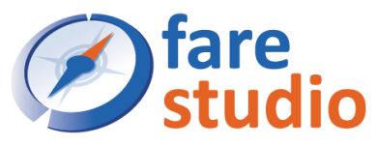

Logo size: Travel Studio
- Minimum 1.75 cm high x 6.9 cm wide for word documents, powerpoint and other areas



Other versions of the logo

A greyscale version of the ODL logo has been created for instances where the red/blue colours are not the background colour dictates that it is impossible to use the standard blue and red version. Please contact the marketing department for guidance if you feel that you need to implement one of these alternative versions.



Fonts

Our primary corporate typeface is Calibri, minimum 11 pt font. This is to be used for all documents and communication, both electronic (email) and printed.

For the ODL website and software, the alternative font to be used is Arial. Further guidelines will be created for this in due course.

Calibri regular | Calibri italics | Calibri bold

Colour scheme

The primary colours of the logo are as follows:

Secondary colours of the logo:

Guidelines for usage:
- The light blue should be used for all primary headings and subheadings, however black is also acceptable.
- The grey colour should be used for tables, footers, lines, etc. where possible.

A number of new colours have also been introduced into the marketing material and website, which will be shared in due course.

Please contact the marketing department for further guidance if you would like help building a new template.

E-mail signature

8.1 Email font instructions

All staff need to adjust their email settings for text as follows:

- Text for all emails
  - Under File/Options/Mail/stationery and fonts
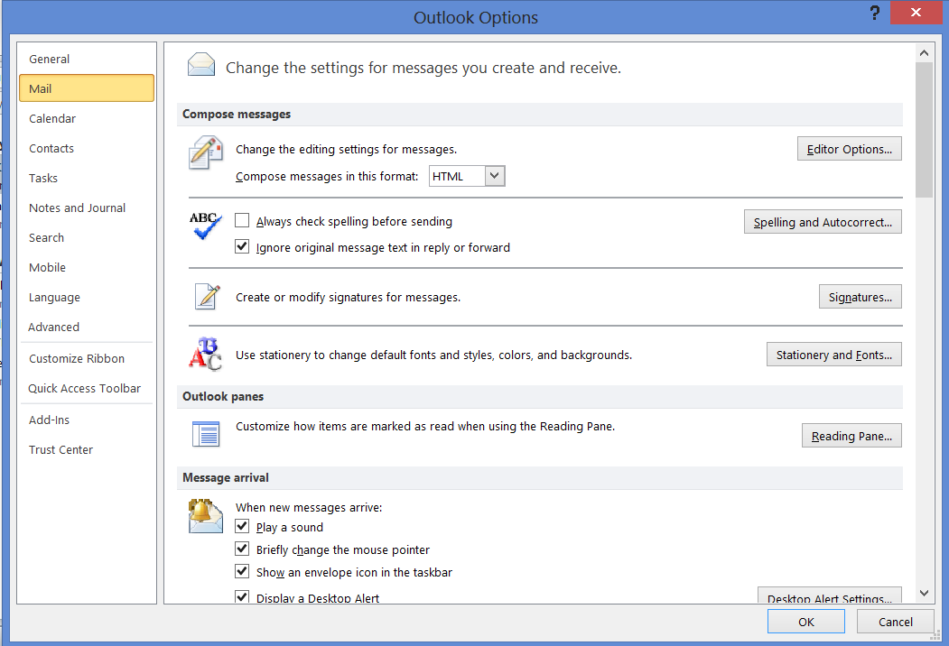

  - Update two areas with Calibri regular font / size 11 / colour - black
    - new mail messages
    - replying or forwarding messages

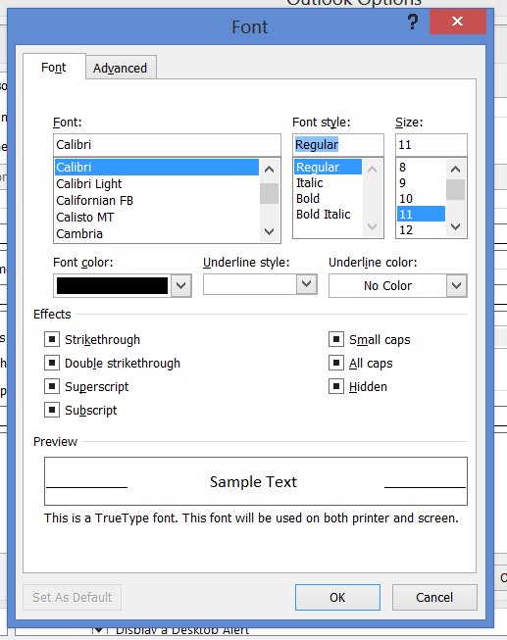
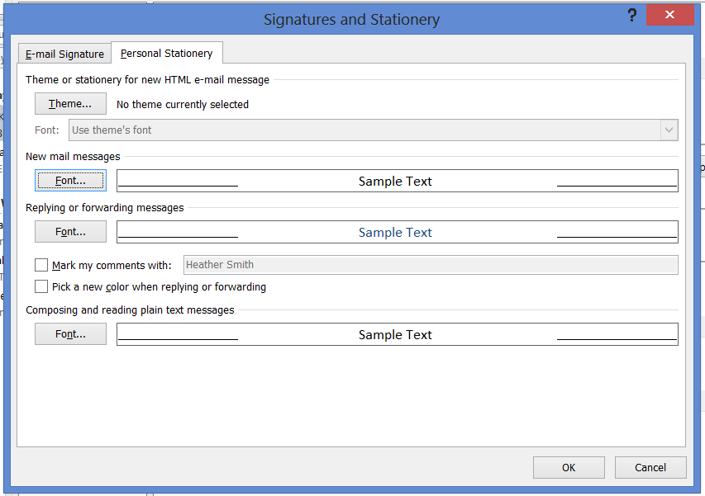

8.2 Email signature instructions

Correct use of our email signature, shown below, will ensure a standard presentation of our brand in all external email communication. Font used in the signature is Calibri 11pt.

Please contact the marketing department if you have any difficulties ensuring that your email signature complies with these guidelines.

Example email signature – please copy and paste this into your outlook

Heather Smith
Marketing Manager

t: +44 (0) 207 553 9220 ext. 244
e: heather@opendestinations.com
w: www.opendestinations.com



Document template guidelines

Templates have been provided by your managers that should cater to your needs, however if you want to create a new document from scratch, please follow these sizing requirements:

Fonts
Main text - Calibri 11 pt
Subheadings - Calibri 12 pt
Headings - Calibri 14 pt
Colours – please refer to section 7

Logos
Size – height 1.75, width depending on whether strapline is used (please refer to section 3)
Text wrap – in front of text

Page setup
Header from top – 1.25 cm
Footer from bottom – 1.25 cm
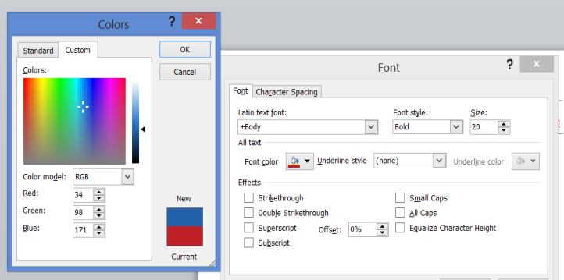
Page margins - T/B/L/R – 1 cm

Do’s and Don’ts *new

- Fonts and colours

Do: use the new colours and fonts for headers and titles

  - ODL Blue : RGB 34/98/171
  - ODL Red: RGB 191/32/38

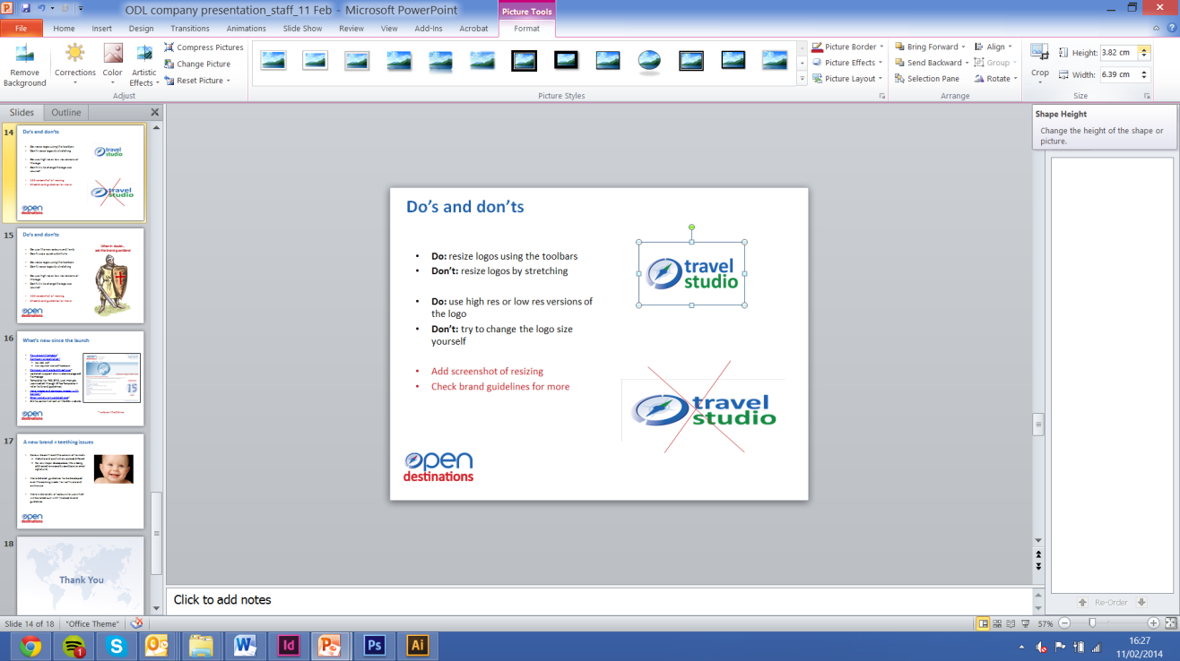
Don’t: use a quick substitute for red and blue

- Logo sizes and versions


Do: resize logos using the toolbars

Don’t: resize logos by stretching

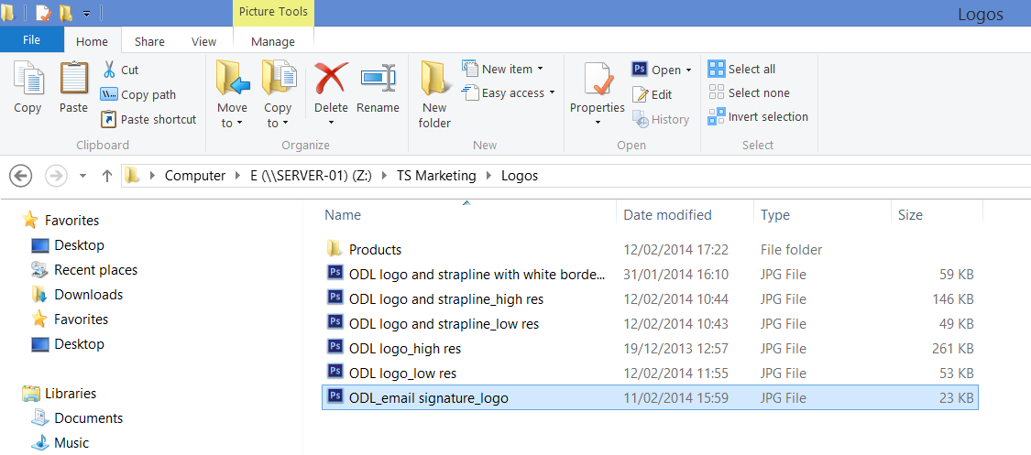
Do: use high res or low res versions of the logo

Don’t: try to change the logo size yourself

Work in progress

We recognise that a new brand takes time to build and as such, the guidelines for the brand will be a work in progress. A more detailed version of the brand guidelines will be circulated in February, to include image guidelines and website guidelines to incorporate for the future.

We welcome your feedback and would appreciate if you could raise any issues to the marketing department as they arise. Please contact Heather at ext 244 or heather@opendestinations.com

How to accessing the new document templates

11.1 Shared Templates

By sharing templates we can all ensure that the documents we create have the same standard of information and design. We recognise that not all documents are the same and the template is only the starting point. You can amend these to fit your requirements without changing the original document.

Please follow the below steps to allow you to use these documents both in and out of the office. This will work for Office 2003, Office 2007 and Office 2010.

Step 1. Locate the following folder Z:\TS Phase Document\_Templates and right click on the “Office Templates” Folder

Step 2. Please right click on the folder marked Office Templates and then click on the “Always Available offline”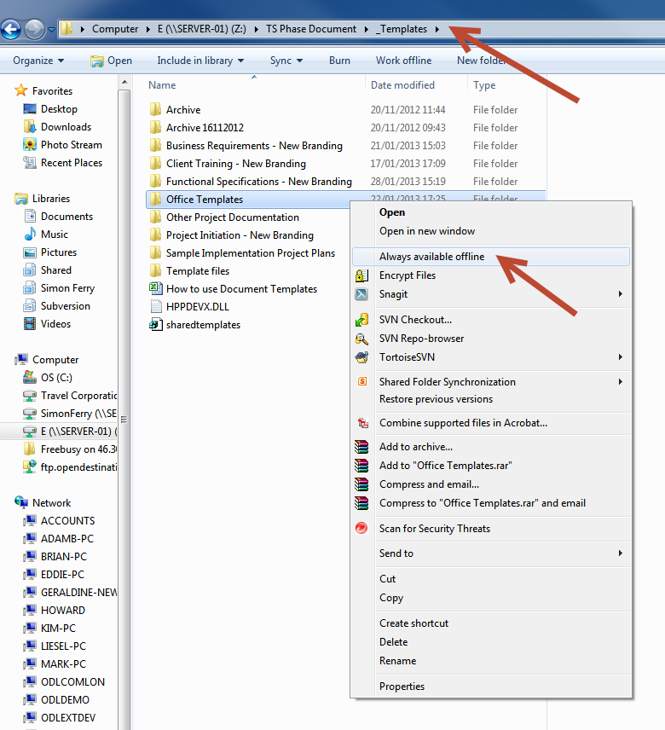

This will sync these folders so that you can access them when you are not in the office.

Note: This can be done with any folder that is located on the server, but do be aware of the folder size!

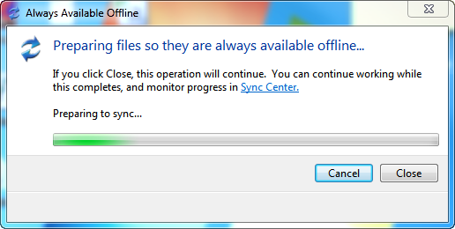

Step 3. You can now close this folder completely

Step 4. Please double click on the SharedTemplates.reg below

You will run through the following screens during this process and it is needed to complete the setup!

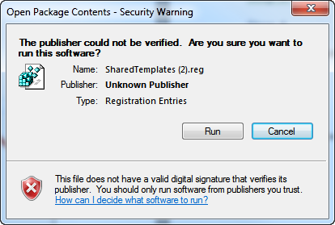
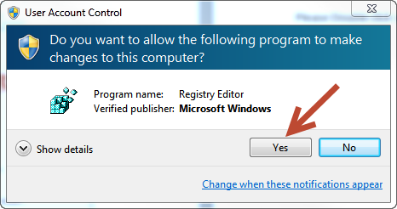

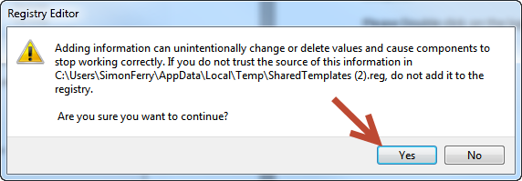

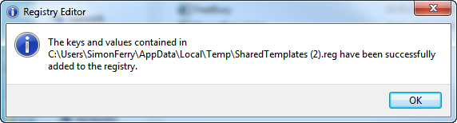

11.2 How to use Templates

From any of the Office programs ‘Word, PowerPoint, Excel, Project, Visio’ you have the ability to use templates to create new documents. First select new document and then click on the ‘My Templates’ as depicted below.

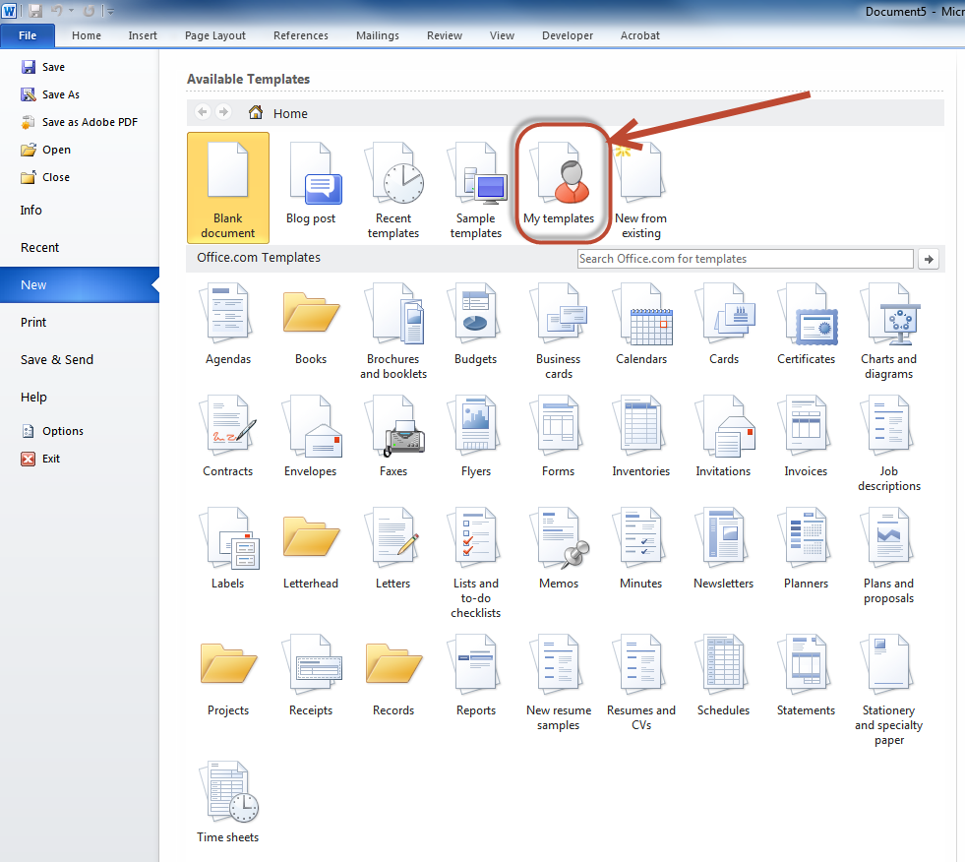

The pop up that is now presented to you has a number of different tabs for the different parts of the business.

- BRD’s
- Functional Spec
- Project
- Training
Each will have different templates in them depending on the program that you are using. i.e There may be no PowerPoint demos for BRD’s so you will not see the folder!
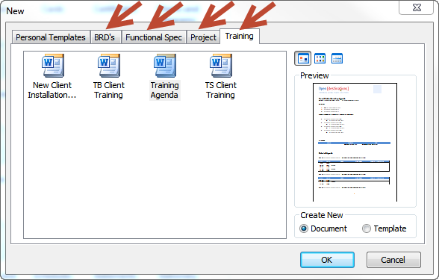

These templates will be updated as needed and will automatically feed into these folders so there is no need for you to search for updated templates.

If you have an issue with any templates please contact either
Simon@opendestinations.com Ext. 241
Heather@opendestinations.com Ext. 244

Templates are there to make your life easier by providing a single location, look and feel. Please ensure that you only use these templates moving forward and not copies of only documents!

